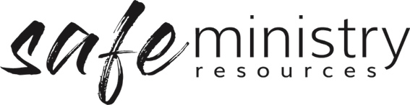

Participant Information Form (SAMPLE)

Child Information
Program Name
Surname First names
Date of Birth Male/female

Parent /Caregiver Information
Surname First names
Address
Mobile Phone Email
Home Phone Work Phone

Medical Information
Please list any medical conditions or allergies, and any medication or special care they require.

Dietary Restrictions
Is your child on a restricted diet? Yes / no
If yes, please indicate foods or beverages your child should not consume:

In Case of Emergency - Contact Numbers
Surname First names
Relationship to Child
Mobile Phone Home/Work Phone
Surname First names
Relationship to Child
Mobile Phone Home/Work Phone

Authorisations
I authorise the leader in charge of this program/event to arrange for my child to receive such first aid and medical treatment as a trained first aid person may deem necessary.
I authorise the use of calling an ambulance by a qualified medical practitioner if in his/her judgment it is necessary.
I accept responsibility for payment of all expenses associated with such treatment.
Please read the following statement and tick the boxes from which you wish to preclude your children:
I DO NOT give permission for my child to participate in activities outside of the church facilities except where they are within reasonable walking distance.
I DO NOT give permission for my child to be transported in private cars arranged by the Ministry Coordinator / Program Leader.
I DO NOT permit photos taken of my child to be displayed on notice boards at church.
I DO NOT permit photos taken of my child to be displayed in publications, e.g. website, newsletters, brochures, etc.
Name _____________________________________
Date
Signature

Version 20200316
Copyright © 2020 Safe Ministry Resources Pty Ltd

The Safe Ministry Framework is developed and owned by SMR Pty Ltd.
It is freely available to churches and denominations to use and adapt with permission.
Please contact SMR Pty Ltd at email info@safercommunities.net.au to seek permission.
SMR can also provide customisation of the Safe Ministry Framework for your church or denomination.

Disclaimer: This publication is not legal advice. The ideas and procedures herein are based on nationally recognised good practice advice for Safe Ministry and have been written with due regard to Australian legislation March 2020.
Legal advice may need to be sought when responding to individual incidents.

