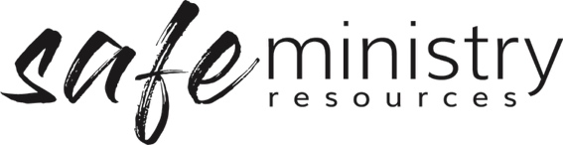

Approval for Programs and Events
Safe programs are transparent and accountable in relation to both procedures and relationships. A safe program ensures that both the physical and emotional environment are safe. Consideration is given to the participants’ ages and cultural backgrounds. Safe programs are prepared for the fact that some activities or situations present more inherent risks than others.
The local church senior leadership is ultimately responsible for any activities that take place in the name of the church. For this reason, the local church senior leadership should approve programs and activities prior to their commencement. There are a number of considerations to be mindful of when establishing a ministry event or program. These considerations might be recorded for accountability purposes in an approval for ministry process.

The Approval for programs/events form is designed to assist in the implementation of this process.

Name of Program: ______________________________________________________________________

Where the program/event takes place: _____________________________________________________

Time of program: ______________________________________________________________________

Ministry Coordinators: ___________________________________________________________________

Program Leader/s Name: _______________________ Contact Ph: ________________

Times available to the team: _______________________________________________

Name: _____________________________ Contact Ph: _________________________

Times available to the team: __________________________________________

Program First Aid person: ________________________________________________

Complete (and attach were appropriate) the following:
- Team list (team is large enough to safely run the program)
- Team have been trained appropriately (eg Safe Ministry training)
- Team have been recruited and forms filed at church
- Housekeeping Risk Assessment Checklist completed
- The individual program risks have been assessed and negated or minimised (Attach safety plans for individual program risks)
- Participant information gathered
- All notes for permission prepared and/or collected (as necessary)
- Program attached (as appropriate)

Version 20200907
Copyright © 2020 Safe Ministry Resources Pty Ltd

The Safe Ministry Framework is developed and owned by SMR Pty Ltd.
This document cannot be modified without express written permission through a licence agreement.
Please contact SMR Pty Ltd at email info@safercommunities.net.au to seek permission.
SMR can also provide customisation of the Safe Ministry Framework for your church or denomination.

Disclaimer: This publication is not legal advice. The ideas and procedures herein are based on nationally recognised good practice advice for Safe Ministry and have been written with due regard to Australian legislation March 2020.
Legal advice may need to be sought when responding to individual incidents.

