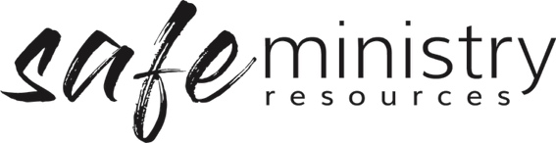

Children’s Feedback Form (SAMPLE)
We’d like you to tell us what you thought
I came to [insert program/event name]
I liked
Something that I thought could be better
Something that I did not like so much was
Would you recommend [insert program/event name] to your friends?
YES / NO / MAYBE (circle one)
Why or why not?

Any other comments?

Thanks for your comments!
Version 20200907
Copyright © 2020 Safe Ministry Resources Pty Ltd

The Safe Ministry Framework is developed and owned by SMR Pty Ltd.
This document cannot be modified without express written permission through a licence agreement. Please contact SMR Pty Ltd at email info@safercommunities.net.au to seek permission.
SMR can also provide customisation of the Safe Ministry Framework for your church or denomination.

Disclaimer: This publication is not legal advice. The ideas and procedures herein are based on nationally recognised good practice advice for Safe Ministry and have been written with due regard to Australian legislation March 2020.
Legal advice may need to be sought when responding to individual incidents.

