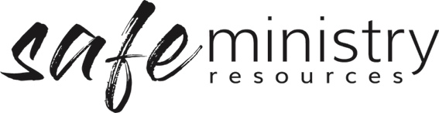

Health and Safety Officer / Team Role Description

Position Description
Dependent upon the size of your church, you will need either a person of team of people appointed to work with the Head of Agency/Organisation/other team members in the implementation of the Safe Ministry Framework in relation to Health & Safety (including compliance with WHS and related legislation where it applies).
For most churches, a team of 2-4 people with appropriate experience and/or skills will be suitable. In the case of smaller churches, this role may be one designated to a single person.
Once appointed the names of the people on the Health and Safety Team should be communicated widely and regularly to the whole local church, for example via email, in newsletters, and on a poster on a wall in your venue.

Selection
- Each person should be appropriately screened, inducted and supervised in this role according to procedure.
- All people who take on this role must complete safe ministry or equivalent training.

Roles
- writing and implementing WHS policies, including privacy policy and evacuations procedures
- keeping WHS on the agenda at meetings of the Management Group and Governance Board
- receiving notifications of hazards/incidents such as serious events and dangerous incidents from workers and visitors
- notifying of incidents such as serious events and dangerous incidents within a prescribed period to the appropriate office holder/s e.g. Governance Board
- addressing health and safety concerns within a reasonable time frame
- undertaking a site safety environment audit of the church at least twice a year

Version 20200907
Copyright © 2020 Safe Ministry Resources Pty Ltd
The Safe Ministry Framework is developed and owned by SMR Pty Ltd.
This document cannot be modified without express written permission through a licence agreement. Please contact SMR Pty Ltd at email info@safercommunities.net.au to seek permission.
SMR can also provide customisation of the Safe Ministry Framework for your church or denomination.

Disclaimer: This publication is not legal advice. The ideas and procedures herein are based on nationally recognised good practice advice for Safe Ministry and have been written with due regard to Australian legislation March 2020.
Legal advice may need to be sought when responding to individual incidents.

