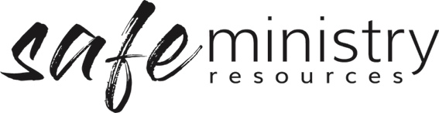
Procedure – Record Keeping
The Safe Ministry Framework Procedure for record keeping relates to the documentation and safe and secure storage of records in relation to keeping all people safe, of reports of concerns about people and of reporting of incidents.
  - In the documentation and storage of records we will take into account the National Privacy Act principles, i.e.
- private information is only collected if necessary;
- individuals concerned are advised of its intended use;
- personal information collected is stored securely and not divulged to others without the consent of the individual involved;
- any personal information the church is holding which is no longer required, is out of date or incorrect, is either destroyed or amended to be accurate
  - The Governance Board will delegate the task of adequate documentation and secure storage of all records to <insert relevant person/s e.g. Management Group/HR>.
  - The <insert relevant person/s e.g. Management Group/HR> is responsible for the implementation of our record keeping procedures.
- Safe Ministry records will be kept in secure (locked or password protected) storage for a period of not less than 45 years.

- The Program Director will collect information using information and permission forms for giving permission in situations including but not limited to:
- collecting, retaining and distributing of personal information of program participants;
- taking photos, displaying photos of attendees in hard copy or electronic forms such as websites or social media sites;
- providing details of persons appearing in photos in either hard or electronic forms.
- Employment records, including all documentation as part of our Safe Ministry Procedures will be securely stored electronically by the <insert relevant person/s e.g. Management Group/HR>.
- Child protection reports and records including all documentation as part of our Safe Ministry Procedures will be securely stored electronically by the Safe Ministry Officer/Team. These records will be kept permanently.
h. Incident reports and records including all documentation as part of our Safe Ministry
i. Procedures will be securely stored electronically by the <insert relevant person/s e.g. Management Group/HR>. These records will be kept permanently.

Version 20200907
Copyright © 2020 Safe Ministry Resources Pty Ltd

The Safe Ministry Framework is developed and owned by SMR Pty Ltd.
This document cannot be modified without express written permission through a licence agreement. Please contact SMR Pty Ltd at email info@safercommunities.net.au to seek permission.
SMR can also provide customisation of the Safe Ministry Framework for your church or denomination.

Disclaimer: This publication is not legal advice. The ideas and procedures herein are based on nationally recognised good practice advice for Safe Ministry and have been written with due regard to Australian legislation March 2020.
Legal advice may need to be sought when responding to individual incidents.

