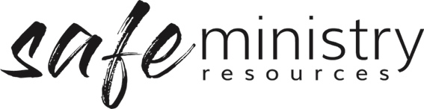
Procedure – Safe Ministry Training and
Resourcing of Workers
The Safe Ministry Framework Procedure for training and resourcing of workers relates to the implementation of the following Policy statement:
We commit to the welfare of all people through the implementation and ongoing improvement of our Safe Ministry Framework which includes: safe and adequate recruitment, training, supervision, support and resourcing of our workers

1. Training

a. Induction Training
All workers will be fully inducted in relation to:
  - Knowledge of operating procedures that apply to equipment, programs and general site health and safety.
  - Code of conduct expectations and appropriate behaviours for workers.

b. Safe Ministry Training
- All workers will receive initial and ongoing training in Safe Ministry training: including empowering and including all people, identifying and responding to children and vulnerable people at risk of harm, and safe environments (duty of care).

c. Ongoing in-service training
- The Management Group will arrange ongoing staff and worker professional development as is appropriate to the worker’s role, e.g. first aid, specific qualifications as necessary for the successful carrying out of the worker’s role.

2 Resourcing of workers
- The Governance Board will ensure the programs of the Church are adequately resourced with human resources and equipment for the safe and effective running of the program.
- The Management Group will ensure that program leaders and workers are resourced with the equipment and qualified persons to run the events and activities that are programmed.
- Workers will report to the Management Group when there’s a shortage of supplies prior to the operation of events and activities, to ensure that these supplies can be replaced for the effective operation of the event or activity.

Version 20200907
Copyright © 2020 Safe Ministry Resources Pty Ltd

The Safe Ministry Framework is developed and owned by SMR Pty Ltd.
This document cannot be modified without express written permission through a licence agreement.
Please contact SMR Pty Ltd at email info@safercommunities.net.au to seek permission.
SMR can also provide customisation of the Safe Ministry Framework for your church or denomination.

Disclaimer: This publication is not legal advice. The ideas and procedures herein are based on nationally recognised good practice advice for Safe Ministry and have been written with due regard to Australian legislation March 2020.
Legal advice may need to be sought when responding to individual incidents.

