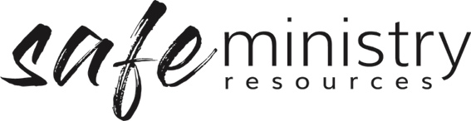
Procedure – Supervision of Workers
The Safe Ministry Framework Procedure for supervision of workers relates to the implementation of the following Policy statement:
we commit to the welfare of all people through the implementation and ongoing improvement of our Safe Ministry Framework which includes: safe and adequate recruitment, training, supervision, support and resourcing of our workers
The Governance Board will provide a system of support and supervision for all our workers, to ensure they feel valued, respected and fairly-treated, including:

1. Provision of up-to-date documentation to workers
- The Management Group will ensure all workers (paid staff and volunteers) have access to the current version of our Safe Ministry Framework Policy and Procedures and relevant code of conduct.

2. Supporting workers
- The Management Group will communicate the types of formal or informal support mechanisms available to workers, so that workers have a clear understanding of to whom they can go for support and what type of support is available to them (e.g. staff meetings, communications processes, processes for accessing counselling or prayer, etc). <insert list formal and informal supports available to workers>

3. Review of position
- All paid workers shall engage in an annual process of position review through a formal written process or review to provide an opportunity for leaders to say they will or will not be available next year/time, which is important for the health of committed teams. <insert review process>
- Volunteers will be provided with an opportunity to access position reviews as required.

4. Codes of conduct

a. Codes of conduct have been developed with the following underlying intentions and commitments:
- To encourage staff members to seek to act at all times in a manner that faithfully represents the ethos and beliefs of the organisation.
- To ensure clear expectations of workers and their alignment with the vision and commitments of the organisation to ensure the safety and well-being of children, teenagers, adults and our church.
- To detail the standards of conduct expected by various persons associated with our church in relation to the performance of their duties and their behaviours.

b. We have three role-specific codes of conduct:
- Workers including staff (paid employees), governance board members, volunteer workers, and casual helpers
- Contractors
- Children who participate in our programs

Version 20200907
Copyright © 2020 Safe Ministry Resources Pty Ltd

The Safe Ministry Framework is developed and owned by SMR Pty Ltd.
This document cannot be modified without express written permission through a licence agreement. Please contact SMR Pty Ltd at email info@safercommunities.net.au to seek permission.
SMR can also provide customisation of the Safe Ministry Framework for your church or denomination.

Disclaimer: This publication is not legal advice. The ideas and procedures herein are based on nationally recognised good practice advice for Safe Ministry and have been written with due regard to Australian legislation March 2020.
Legal advice may need to be sought when responding to individual incidents.

