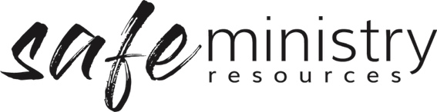

Safe Ministry Officer/Team Role Description
Dependent upon the size of your church, you will need either a person or team of people appointed to work with the Head of Agency, Health & Safety Officer/Team / Program Director/ other team members in the implementation of the Safe Ministry Framework.

Selection
- If there is to be a team, the Head of Agency/Organisation will need to be a part of this team or be adequately involved in decision making (The Head of Agency/Organisation is responsible and may be liable for ensuring correct procedure is followed)
- The role is not only a safe ministry concerns reporting role, but rather implementation/oversight of procedure role.
- The role has a coordination of pastoral care and risk management elements to it.
- A senior person in the organisation should fulfil this role, in larger organisations where there is to be a team, 1-3 other suitably qualified persons to bring a mix of gender and skills to the team, such pastoral, social work/counselling and legal representation is advisable (where possible).
- All people who take on this role must complete safe ministry or equivalent training.

Role Description General
- to be the agency/organisation’s hub for safe ministry
- assist workers in dealing with safe ministry concerns that arise
- to promote awareness of and adherence to the agency/organisation’s Safe Ministry Framework

Specific Roles

a. Implementation of Safe Ministry Framework
- implementing the Safe Ministry Framework within the organisation/agency
- preparing reports for Governance Board meetings on safety
- keeping records relating to the Safe Ministry Framework

b. Reporting
- receiving concerns from workers
- supporting workers in following the procedure for responding to safe ministry concerns
- contacting the relevant person in the organisation (e.g. Head of Agency/ Organisation/ Program Leader) to discuss action plan/appropriate action
- making any reporting calls (to government agencies) as required
- ensuring the concern and subsequent response has been appropriately documented
- in the event of a complaint or concern regarding a worker:
    - informing the Head of Agency/Organisation
    - assisting in pastoral, legal, procedural and risk management of the matter
- keeping records, filing complaints and reports of investigations in a secure central file, in accordance with the record keeping procedure
Version 20200907
Copyright © 2020 Safe Ministry Resources Pty Ltd

The Safe Ministry Framework is developed and owned by SMR Pty Ltd.
This document cannot be modified without express written permission through a licence agreement. Please contact SMR Pty Ltd at email info@safercommunities.net.au to seek permission.
SMR can also provide customisation of the Safe Ministry Framework for your church or denomination.

Disclaimer: This publication is not legal advice. The ideas and procedures herein are based on nationally recognised good practice advice for Safe Ministry and have been written with due regard to Australian legislation March 2020.
Legal advice may need to be sought when responding to individual incidents.

