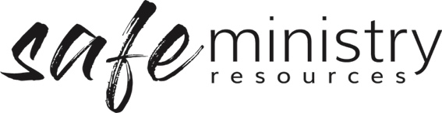

Safe Ministry Policy and Procedure Implementation & Review Schedule

Framework element | Implemented (date) | People/person responsible | Review due
Implementation of policy/procedure
Safe Ministry Framework Policy
Safe Ministry Framework implementation procedure
Participation & inclusion of children and their caregivers
Recruitment & appointment of workers
Training & resourcing of workers
Supervision of workers
Codes of conduct implemented
Safe environments
Responding to child protection concerns (child safety specific)
Responding to Safe Ministry concerns about an adult
Responding to incidents & emergencies
Record-keeping
Resolving misunderstandings and conflicts
Workplace investigation
Appointment / induction into roles
Safe Ministry Officer/Team
Head of Agency/Organisation
Health & Safety Officer/Team
Ministry Coordinator/Program Leader/s
Management Group
Team Members

Version 20200907
Copyright © 2020 Safe Ministry Resources Pty Ltd

The Safe Ministry Framework is developed and owned by SMR Pty Ltd.
This document cannot be modified without express written permission through a licence agreement. Please contact SMR Pty Ltd at email info@safercommunities.net.au to seek permission.
SMR can also provide customisation of the Safe Ministry Framework for your church or denomination.

Disclaimer: This publication is not legal advice. The ideas and procedures herein are based on nationally recognised good practice advice for Safe Ministry and have been written with due regard to Australian legislation March 2020.
Legal advice may need to be sought when responding to individual incidents.

