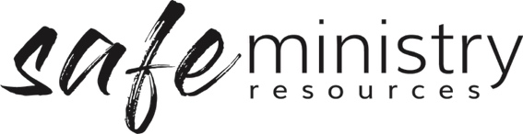

Site Safety Expectations Poster
(Contractor & Guests)
(Use this information for a small sign to sit next to the contractor sign in booklet – 4.15)

Our church is a safe place for everyone.

We expect all contractors and visitors to
- respect each other
- care for each other’s safety
- report any concerns about people’s safety to their contact person

To ensure the safety of all people
- there is to be no unsupervised visitor alone with a child or group of children
- all visitors must sign in and declared that they are a safe person, and that they will act in safe ways towards others

Version 20200907
Copyright © 2020 Safe Ministry Resources Pty Ltd

The Safe Ministry Framework is developed and owned by SMR Pty Ltd.
This document cannot be modified without express written permission through a licence agreement.
Please contact SMR Pty Ltd at email info@safercommunities.net.au to seek permission.
SMR can also provide customisation of the Safe Ministry Framework for your church or denomination.

Disclaimer: This publication is not legal advice. The ideas and procedures herein are based on nationally recognised good practice advice for Safe Ministry and have been written with due regard to Australian legislation March 2020.
Legal advice may need to be sought when responding to individual incidents.

