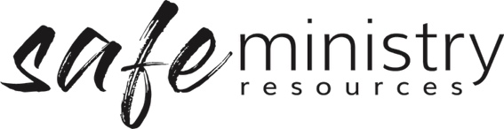

Workplace Health and Safety Policy (SAMPLE)
The <insert your church name> recognises its moral and legal responsibility to provide a safe and healthy work environment for everyone.
All people at church will endeavour to do nothing to place themselves or others at risk of emotional or physical injury or illness.
The church senior leadership (board of management) will endeavour to:
• Provide a safe workplace including a safe site and ministry programs
• Ensure compliance with legislative requirements and standards
• Provide workers (volunteers and paid) and contractors with information, instruction, training and supervision for their safety
• Provide support that will assist workers in maintaining their psychological and physical health
• To implement Work Health and Safety policies and procedures
• Actively promote and be involved in the implementation of those policies and procedures
Church workers (volunteer and paid) are responsible for:
• Following all health and safety policies and procedures
• Reporting all hazards identified to the Health and Safety team
• Complying with reasonable instructions
• Not behaving in a wilful or reckless manner

The church is committed to encouraging consultation and cooperation between pastors, church administrators, employees and voluntary workers. It will involve all parties in workplace changes likely to affect their safety, health and welfare.
Approved:
Name/role: …………………………………………………………………………………….
Date: …………/…………./………………

Version 20200907
Copyright © 2020 Safe Ministry Resources Pty Ltd

The Safe Ministry Framework is developed and owned by SMR Pty Ltd.
This document cannot be modified without express written permission through a licence agreement. Please contact SMR Pty Ltd at email info@safercommunities.net.au to seek permission.
SMR can also provide customisation of the Safe Ministry Framework for your church or denomination.

Disclaimer: This publication is not legal advice. The ideas and procedures herein are based on nationally recognised good practice advice for Safe Ministry and have been written with due regard to Australian legislation March 2020.
Legal advice may need to be sought when responding to individual incidents.

