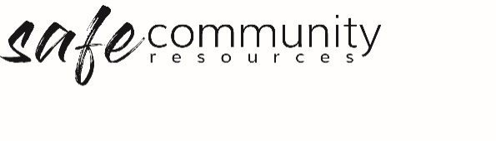

Approval for Program / Event
Safe programs are transparent and accountable in relation to both procedures and relationships. A safe program ensures that both the physical and emotional environment are safe. Consideration is given to the participants’ ages and cultural backgrounds. Safe programs are prepared for the fact that some activities or situations present more inherent risks than others.
The organisation’s Head of Agency /Entity is ultimately responsible for any activities that take place in the name of the organisation. For this reason, the Head of Agency/ Entity should approve programs and activities prior to their commencement. There are a number of considerations to be mindful of when establishing an event or program. These considerations might be recorded for accountability purposes in an approval for program / event process.

The Approval for Program / Event form is designed to assist in the implementation of this process.

Name of Program: ______________________________________________________________________

Where the program/event takes place: _____________________________________________________

Time of program: ______________________________________________________________________

Program / Event Coordinators: ___________________________________________________________________

Program Leader/s Name: _______________________ Contact Ph: ________________

Times available to the team: _______________________________________________

Name: _____________________________ Contact Ph: _________________________

Times available to the team: __________________________________________

Program First Aid person: ________________________________________________

Complete (and attach were appropriate) the following:
- Team list (team is large enough to safely run the program)
- Team have been trained appropriately (e.g. Child protection)
- Team have been recruited and forms filed at organisation
- Housekeeping Risk Assessment Checklist completed
- The individual program risks have been assessed and negated or minimised (Attach safety plans for individual program risks)
- Participant information gathered
- All notes for permission prepared and/or collected (as necessary)
- Program attached (as appropriate)

Copyright © 2020 Safe Ministry Resources Pty Ltd

The Safe Community Framework is developed and owned by SMR Pty Ltd.
This document cannot be modified without express written permission through a licence agreement. Please contact Safe Community Resources at info@safercommunities.net.au to seek permission.
Safe Community Resources can also provide customisation services to your organisation in the area of implementation of the Safe Community Framework for your organisation.

Disclaimer: This publication is not legal advice. The ideas and procedures herein are based on nationally recognised good practice advice and have been written with due regard to Australian legislation March 2020.
Legal advice may need to be sought when responding to individual incidents.

