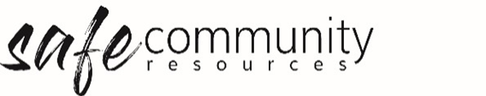
Children’s Feedback Form
We’d like you to tell us what you thought
I came to [insert program/event name]
I liked
Something that I thought could be better
Something that I did not like so much was
Would you recommend [insert program/event name] to your friends?
YES / NO / MAYBE (circle one)
Why or why not?

Any other comments?

Thanks for your comments!

Copyright © 2020 Safe Ministry Resources Pty Ltd

The Safe Community Framework is developed and owned by SMR Pty Ltd.
This document cannot be modified without express written permission through a licence agreement.
Please contact Safe Community Resources at info@safercommunities.net.au to seek permission.
Safe Community Resources can also provide customisation services to your organisation in the area of implementation of the Safe Community Framework for your organisation.

Disclaimer: This publication is not legal advice. The ideas and procedures herein are based on nationally recognised good practice advice and have been written with due regard to Australian legislation March 2020.
Legal advice may need to be sought when responding to individual incidents.

