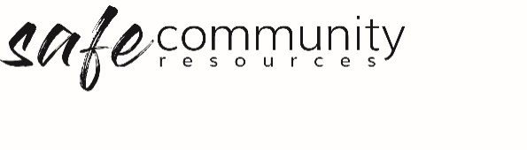

Hazard Identification Form (SAMPLE)

A hazard is a source of danger that could result in an accident if undue care is not exercised.

Where risk assessment considers things that might be a risk or go wrong during an organisational activity, hazard identification and control measures relate to actual hazards that are present prior to the commencement of an organisational activity.

Where a hazard is identified, it is important to decide upon one or more measures that can be used to control or eliminate the hazard. These measures are referred to as Hierarchy of Control measures. The table below provides an overview of the elimination or control measures that may be used to address a hazard, along with some descriptions that may be aligned with each measure.

Hierarchy of Control Measures
Elimination or control measures | General description
Eliminate the hazard | Remove the hazard. Change the activity or stop using it
Substitute the hazard | Replace the activity, material, or equipment with a less hazardous one
Isolate the hazard | Isolate the hazard from the person at risk; isolate through distance.
Use engineering controls | Change the physical characteristics of the environment (with additions or subtractions) to remove or reduce the risk
Use administrative controls | Establish procedures and safe practices
Use personal protective equipment | Use appropriately designed and properly fitted equipment and clothing

There are numerous ways to record hazards and control measures that have been implemented. The template on the following page may be used as one way of keeping written records of hazards and measures used.

Hazard Identification Form
<insert your church name>

Date:
Venue:
Organisation
Co-ordinator:
Contact details:

Hazard details | Control measure implemented
Example:  Legs of projector stand protruding into floor space | Engineering control - Place chairs over protruding legs  Administrative control – draw hazard to the attention of children or young people and leaders and request they are cautious when moving near the area

Report submitted by

Follow-up action if required

Person responsible for follow up |  | Date due

Copyright © 2020 Safe Ministry Resources Pty Ltd

The Safe Community Framework is developed and owned by SMR Pty Ltd.
This document cannot be modified without express written permission through a licence agreement. Please contact Safe Community Resources at info@safercommunities.net.au to seek permission.
Safe Community Resources can also provide customisation services to your organisation in the area of implementation of the Safe Community Framework for your organisation.

Disclaimer: This publication is not legal advice. The ideas and procedures herein are based on nationally recognised good practice advice and have been written with due regard to Australian legislation March 2020.
Legal advice may need to be sought when responding to individual incidents.

