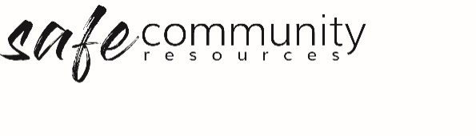

Management Group Member
Role Description
Dependent upon the size of your organisation, you will need either a person or a team of people appointed to work with the Head of Agency/ Entity/ Organisation, Safe Community Officer/Program Director/ other team members in the implementation of the Safe Community Framework

Selection
- Each Management Group member should be appropriately screened, inducted and supervised in this role according to procedure.
- Management Group members must complete child protection training and be inducted in the Safe Community Framework documentation.

Roles
- This role will greatly depend on the size of your organisation and may include:
- overall responsibility for implementation of the Framework
- liaising with or being a part of the Safe Community Team and/or Health & Safety Team
- maintaining a positive, and safe culture
- reporting regularly to the Governance Board in relation to implementation of the Framework

Copyright © 2020 Safe Ministry Resources Pty Ltd

The Safe Community Framework is developed and owned by SMR Pty Ltd.
This document cannot be modified without express written permission through a licence agreement. Please contact Safe Community Resources at info@safercommunities.net.au to seek permission.
Safe Community Resources can also provide customisation services to your organisation in the area of implementation of the Safe Community Framework for your organisation.

Disclaimer: This publication is not legal advice. The ideas and procedures herein are based on nationally recognised good practice advice and have been written with due regard to Australian legislation March 2020.
Legal advice may need to be sought when responding to individual incidents.

