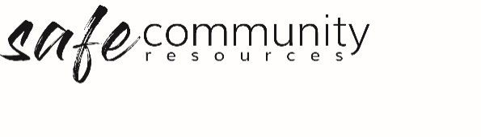

Parents / Caregivers Feedback Form (SAMPLE)
Your opinion matters to us. Please take a few minutes to talk to your child/ren about [insert program/event name] and them email us some feedback. You might like to use these questions to guide your comments.
Rate your child/children’s overall experience at [insert program/event name]
- excellent b. good c. fair d. poor e. terrible
What was done well at [insert program/event name]?

What did your child like the most about [insert program/event name]?

What can we do better?

Any specific concerns you have and why?

Any other comments

Copyright © 2020 Safe Ministry Resources Pty Ltd

The Safe Community Framework is developed and owned by SMR Pty Ltd.
This document cannot be modified without express written permission through a licence agreement.
Please contact Safe Community Resources at info@safercommunities.net.au to seek permission.
Safe Community Resources can also provide customisation services to your organisation in the area of implementation of the Safe Community Framework for your organisation.

Disclaimer: This publication is not legal advice. The ideas and procedures herein are based on nationally recognised good practice advice and have been written with due regard to Australian legislation March 2020.
Legal advice may need to be sought when responding to individual incidents.

