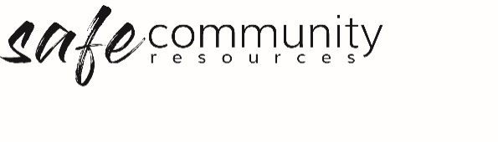

Procedure – Responding
to Child Protection Concerns
The Safe Community Framework Procedure for responding to child protection concerns relates to the implementation of the following Policy statement:
We commit to the welfare of all people through the implementation and ongoing improvement of our Safe Community Framework which includes: appropriate and expedient responses to all incidents, accidents, child protection and/or safe community (misconduct and abuse) concerns.

1. Child-centred approach to reporting
We commit to a child centred approach to responding to concerns about a child or group of children who may be at risk of harm.
We start with the question: “How is the child experiencing the suspected or actual harm?” and then act in the best interests of the child.

2 Workers will report (as soon as is practicable) when:
- someone discloses that they are being harmed or are at risk of being harmed
- another person discloses that a person is being harmed or is at risk of being harmed
- the worker has a reasonable concern that a person is at risk of harm (based on the indicators of risk of harm)
Definition of reasonable concern: Concern that a person or group of people is at risk of any form of physical and/or emotional ill-treatment, sexual abuse, neglect or negligent treatment, or commercial or other exploitation which is likely to result in harm to health, survival, development or dignity of the person or group of people.

3. How to respond

a. Report to your Safe Community Officer/Team
i. When a disclosure occurs or a person’s immediate safety is at risk (sexual and physical abuse), go directly to the Program Leader, who will in turn phone the police (local or 000) and also organise immediate appropriate support for the person.
b. The Safe Community Officer/Team completes a Safe Community Concerns Record (Sample Safe Community Concerns Anecdotal Record – Implementation Forms).
c. The Safe Community Officer/Team takes appropriate actions (care, legal, organisational and risk management). Including:
- Contacting denomination [delete if not governed by a denomination]
- Completing any reporting to government child protection agencies (Note: In SA the person who has the concern or received the disclosure must make the report to the Child Abuse Report Line).
- Additional reporting (police, government agency such as an Children’s Commission / Office of the Children’s Guardian / Ombudsman) and/or completing workplace investigation (where the allegation is against a worker, if in state or territory where Reportable Conduct Scheme is legislated, follow the timelines for reporting in that state or territory)

d. Disclosures - “Dos and Don’ts” – for workers – relevant for first-hand disclosures from a child or second-hand disclosures from either a child or adult about a child.
Do:
- Listen … do not add anything to what the person says (you will need to write this down, exactly)
- Believe ... the person and what they are telling you.
- Reassure … the person that they have done the right thing in speaking to you
- Inform … the person that you need to tell people who will try to help
- Ensure … that the person is not in immediate danger
Don’t:
- Start an investigation re the information, do not ask leading questions, i.e. questions that have a yes or no answer
- Promise the person that the abuse will stop
- Tell anyone who does not need to know
Note: Keep it brief. Do not have a long conversation, as this may be seen to have influenced the information, which may jeopardise an investigation.

Copyright © 2020 Safe Ministry Resources Pty Ltd

The Safe Community Framework is developed and owned by SMR Pty Ltd.
This document cannot be modified without express written permission through a licence agreement.
Please contact Safe Community Resources at info@safercommunities.net.au to seek permission.
Safe Community Resources can also provide customisation services to your organisation in the area of implementation of the Safe Community Framework for your organisation.

Disclaimer: This publication is not legal advice. The ideas and procedures herein are based on nationally recognised good practice advice and have been written with due regard to Australian legislation March 2020.
Legal advice may need to be sought when responding to individual incidents.

