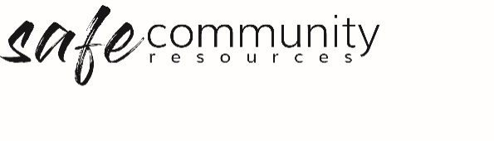

Procedure – Responding
to Incidents and Emergencies
The Safe Community Framework Procedure for responding to incidents and emergencies relates to the implementation of the following Policy statement:
We commit to the welfare of all people through the implementation and ongoing improvement of our Safe Community Framework which includes: appropriate and expedient responses to all incidents, accidents, child protection and/or safe community (misconduct and abuse) concerns.
- Incidents and critical incident response procedures form part of our overall site safety procedures as found in our <insert the name of your organisation's document in which WHS, risk management and safety procedures are found>.
- Our response to incident procedures management applies to our common law duty of care, Work Health & Safety and specifically to the minimising of safety risks for all people who are in our care.
- The Governance Board will delegate the task of management of incidents and critical incidents to <insert relevant person/s or group e.g. Management Group / Work Health & Safety Officer>
- The <insert relevant risk management person/s or group e.g. Management Group/Work Health & Safety Officer> is responsible for the implementation of our incident and critical incident procedures.
- General
- Every incident will require immediate response, in the moment, as well as follow up over the next 12-24 hours (or longer), including care for those involved.
- Review will need to determine the reason for the incident, and changes should be made to minimise the risk of the same incident occurring the next time the same activity/event is run.
- Injuries or accidents which require secondary medical attention e.g. visit to a doctor or medical centre should be written up on an Accident & Incident Report Form
- Report all incidents to parents and/or caregivers of children and vulnerable adults, and in some instances, where the impact has been felt by a wider group, reporting to the wider concerned group may be done with the permission of those involved in the incident.

Specific procedures
<Insert a list of your all of your organisation's procedures, as found in your operation manual: e.g. first aid procedures, loss of participant procedure, outbreak of disease (e.g. vomiting bug), fire response – evacuation plan, critical incidents e.g. near death or death of participant>
Note: This is not an exhaustive list. This section will need to be customised to ensure that all foreseeable incidents which are serious have a procedure.

Copyright © 2020 Safe Ministry Resources Pty Ltd

The Safe Community Framework is developed and owned by SMR Pty Ltd.
This document cannot be modified without express written permission through a licence agreement.
Please contact Safe Community Resources at info@safercommunities.net.au to seek permission.
Safe Community Resources can also provide customisation services to your organisation in the area of implementation of the Safe Community Framework for your organisation.

Disclaimer: This publication is not legal advice. The ideas and procedures herein are based on nationally recognised good practice advice and have been written with due regard to Australian legislation March 2020.
Legal advice may need to be sought when responding to individual incidents.

