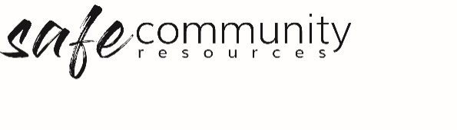

Responsibilities in Relation to
Reportable Employee Conduct Schemes
This is a legislated position in some jurisdictions in relation to the reportable employee conduct schemes which exist in NSW, the ACT and Victoria.
The following descriptions are provided by the relevant government websites:

NSW - Head of Relevant Entity
The Responsibilities of the Head of Relevant Entity can be found online at the OCG website in Reportable Conduct fact sheet 2 https://www.kidsguardian.nsw.gov.au/child-safe-organisations/reportable-conduct-scheme/fact-sheets
In some instances, the head of relevant entity may not be obvious, and the entity should contact the NSW OCG advice.
A head of relevant entity can nominate a contact person for day-to-day correspondence or inquiries and delegate tasks during the process.
ACT – Responsibilities of the Head of Agency
(Source: https://www.ombudsman.act.gov.au/__data/assets/pdf_file/0012/81003/No.-5-Employer-responsibilities.pdf accessed 29 June 2020)
• notify the Ombudsman of reportable allegations or convictions made against an employee, what action the employer intends to take and for what reason. Reports should be made as soon as possible but no later than 30 days after the employer becomes aware of the allegation. (See s 17G Notification on the website.)
• ensure systems, policies and procedures are in place for recording and responding to or investigating allegations or convictions involving reportable conduct against employees.
• establish systems that require employees to notify the employer (or delegate), as soon as possible, of any concern, allegation or conviction of reportable conduct involving an employee, of which they become aware
• ensure ACT Policing and/or Child and Youth Protection Services are notified of allegations as appropriate in the first instance.
• provide to the Ombudsman on request, documentary and other information (including records of interviews) with respect to an investigation being undertaken
• forward to the Ombudsman the results of an investigation, including copies of reports, evidence gathered and considered, the findings reached and action being taken or proposed to be taken as a result of an investigation

Victoria- Head of Organisation
The Responsibilities of the Head of Organisation can be found online at the Victorian Commission for Children and Young People website https://ccyp.vic.gov.au/reportable-conduct-scheme/for-organisations/#TOC-3, the role includes:
- respond to a reportable allegation made against a worker or volunteer from their organisation, by ensuring that allegations are appropriately investigated
- report allegations which may involve criminal conduct to the police
- notify us of allegations within three business days after becoming aware of the allegation
- give us certain detailed information about the allegation within 30 days after becoming aware of the allegation
- after the investigation has concluded, give us certain information including a copy of the findings of the investigation.

Copyright © 2020 Safe Ministry Resources Pty Ltd

The Safe Community Framework is developed and owned by SMR Pty Ltd.
This document cannot be modified without express written permission through a licence agreement.
Please contact Safe Community Resources at info@safercommunities.net.au to seek permission.
Safe Community Resources can also provide customisation services to your organisation in the area of implementation of the Safe Community Framework for your organisation.

Disclaimer: This publication is not legal advice. The ideas and procedures herein are based on nationally recognised good practice advice and have been written with due regard to Australian legislation March 2020.
Legal advice may need to be sought when responding to individual incidents.

