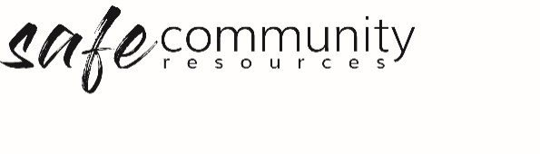

Risk Assessment Template

*Insert Organisation Name*

Activity Risk Assessment / Management

Description of Activity

General | Key: 1 – low, 5 – high
To what degree is there potential for physical or emotional harm to the child, young person and/or leaders? | 1 | 2 | 3 | 4 | 5
To what degree is there potential to create personal discomfort for children, young people or leaders? | 1 | 2 | 3 | 4 | 5
To what degree is there potential for the activity to become emotionally or physically out of control? | 1 | 2 | 3 | 4 | 5
To what degree are the leaders confident that they know what the possible outcomes of activity might be? | 1 | 2 | 3 | 4 | 5
To what degree is there potential that the leader may lose control of the activity, resulting in one or more children or young people [or the leader] being subject to trauma from others? | 1 | 2 | 3 | 4 | 5

Overall level of risk for this activity | High | Medium | Low

General Information | Yes | No
Does the benefit of this activity outweigh the possible risks that may be involved for the child, young person, leader or organisation?
Can the activity be modified to reduce the possible risks?
Are there critical incident and emergency procedures in place if required?
Does the organisation have suitably trained people to address critical incidents or emergencies?
Has this activity been approved by the organisation?
Has this activity been approved by the organisation's insurer?

Strategies
What strategies have been implemented to reduce the risk of this activity?
(add extra pages if applicable)

Copyright © 2020 Safe Ministry Resources Pty Ltd

The Safe Community Framework is developed and owned by SMR Pty Ltd.
This document cannot be modified without express written permission through a licence agreement. Please contact Safe Community Resources at info@safercommunities.net.au to seek permission.
Safe Community Resources can also provide customisation services to your organisation in the area of implementation of the Safe Community Framework for your organisation.

Disclaimer: This publication is not legal advice. The ideas and procedures herein are based on nationally recognised good practice advice and have been written with due regard to Australian legislation March 2020.
Legal advice may need to be sought when responding to individual incidents.

