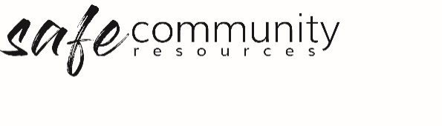

Safe Community Concerns Record
The completed form should be given to the Safe Community Officer.
Name of person filling in this form __________________________________________________
Contact details __________________________________________________
Name of the person about whom you have a concern ___________________________________
Age of person about whom you have a concern ________________________________________
Reporter’s relationship to the person about whom you are concerned _______________________
Describe your concerns, what was observed or what was said.
It is important to provide as much information as possible, basing your information on facts and observations, without making assumptions or jumping to conclusions or making “value” judgments. If a disclosure has been made, a verbatim (word for word) account must be written of the disclosure to the best of the reporter’s ability, as soon after the disclosure as is practical.

Time and date of the incident or recording
Date Time ______________
Signature

This confidential record is to be kept in accordance with privacy legislation.
Copyright © 2020 Safe Ministry Resources Pty Ltd

The Safe Community Framework is developed and owned by SMR Pty Ltd.
This document cannot be modified without express written permission through a licence agreement.
Please contact Safe Community Resources at info@safercommunities.net.au to seek permission.
Safe Community Resources can also provide customisation services to your organisation in the area of implementation of the Safe Community Framework for your organisation.

Disclaimer: This publication is not legal advice. The ideas and procedures herein are based on nationally recognised good practice advice and have been written with due regard to Australian legislation March 2020.
Legal advice may need to be sought when responding to individual incidents.

