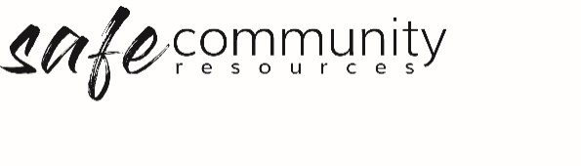

Procedure – Safe Community
Framework Implementation

The Safe Community Framework Implementation Procedure relates to the appointment of persons to Safe Community positions, and mechanisms for program approval, communication, reporting, review and improvement of Safe Community Framework Policy, Procedures, Codes of Conduct and Implementation forms.

1 Appointment of Safe Community Personnel
- The Governance Board/ Director will appoint current personnel or, where necessary, engage new workers to carry out the following Safe Community Framework implementation roles, and review these roles annually:
  - Safe Community Officer/Team
  - Head of Agency /Entity / Organisation
  - Health & Safety Officer/Team
  - Safe Community Coordinator/Program Leader.
- Role descriptions for these roles can be found in Implementation Forms.
- The Governance Board will adequately communicate the names of the persons holding these roles to all workers and members at <name of organisation> (e.g. Implementation Forms - Safe Community Poster).

2 Approving Programs and Events
- The Governance Board <or equivalent> will ensure that, prior to commencement, a written approval for all programs and events of <name of organisation> is undertaken.
- This process will include: ensuring that all duty of care issues have been addressed and all foreseeable program/event risks have been identified, assessed and treated.
3 Communication of the Safe Community Framework
- The Organisation’s Governance Board will ensure documentation for our Safe Community Framework will be made available through our website.
- We will communicate targeted, relevant and specific information about our Safe Community Framework to all persons associated with <name of organisation>.
- The Management Group will ensure that age appropriate signage is posted to provide information about who people (children and adults) can speak with if they have a concern.

4 Reporting to Management Group and Governance Board
- The Governance Board will have a set agenda item for reporting on Safe Community issues at all board meetings.
- The Management Group will have set agenda item for reporting on Safe Community issues at each meeting.
- The Safe Community Coordinators, Health & Safety Officer/Team and Safe Community Officer/Team will report quarterly to the Management Group as to the implementation of the Safe Community Procedures.

5 Review of Safe Community Framework
- The Governance Board will receive an annual report from the Management Group as to the progress of implementation of the Safe Community Framework.
- Every second year the Management Group will undertake a review of the Safe Community Framework.
- This review will include receiving feedback and advice concerning the implementation of the Safe Community Framework from the [denomination where this relationship exists], Safe Community Coordinators, Safe Community Officer/Team, staff, children, parents, caregivers and congregation members as appropriate.
- The review will be presented to the Governance Board for amendment of the Safe Community Framework as deemed appropriate for the protection and safety of all people.

Copyright © 2020 Safe Ministry Resources Pty Ltd

The Safe Community Framework is developed and owned by SMR Pty Ltd.
This document cannot be modified without express written permission through a licence agreement.
Please contact Safe Community Resources at info@safercommunities.net.au to seek permission.
Safe Community Resources can also provide customisation services to your organisation in the area of implementation of the Safe Community Framework for your organisation.

Disclaimer: This publication is not legal advice. The ideas and procedures herein are based on nationally recognised good practice advice and have been written with due regard to Australian legislation March 2020.
Legal advice may need to be sought when responding to individual incidents.

