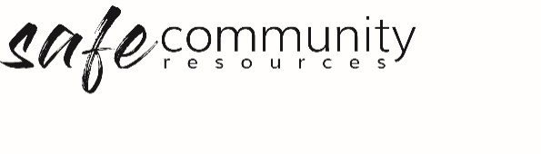

Safe Community Implementation Checklist
(circle ‘Done’ or ‘To Do’ for each)
1. | Has the organisation adopted an overarching Safe Community Policy? | Done / To Do
2. | Has the organisation communicated the Safe Community Policy to all workers and participants in the organisation? | Done / To Do
3. | Is it a requirement of your organisation that all workers attend a child protection workshop? | Done / To Do
4. | Do you have an appointed Safe Community Officer / Team? | Done / To Do
5. | Do you have a Health and Safety Officer / Team? | Done / To Do
6. | Do you have a procedure for screening, appointing and inducting workers (paid and volunteer)? | Done / To Do
7. | Have all your paid workers been recruited according to your procedure? | Done / To Do
8. | Do you have a code of conduct for all organisation workers (paid and volunteer)? | Done / To Do
9. | Do you undertake induction and ongoing training in the code of conduct? | Done / To Do
10. | Do you have clear procedures for handling complaints and grievances? | Done / To Do
11. | Do your workers use a procedure for reporting of safe community (e.g. child protection) concerns? | Done / To Do
12. | Do all your workers (paid and volunteer) have annual reviews? | Done / To Do
13. | Do all workers know what to do in the case of a disclosure of illegal activity? | Done / To Do
14. | Have you made your workers aware of the failure to report / failure to protect legislation? | Done / To Do
15. | Does your organisation have procedures to ensure there are no known sexual offenders working (including volunteers) in your organisation? | Done / To Do
16. | Is there a documented procedure for accessing assistance in the case of emergency? | Done / To Do
17. | Are there health & safety procedures in place (WHS)? | Done / To Do
18. | Do you have record keeping procedure, including the collection and storage of personal information? | Done / To Do
19. | Are there organisation-wide incident response procedures (critical and other)? | Done / To Do

Copyright © 2020 Safe Ministry Resources Pty Ltd

The Safe Community Framework is developed and owned by SMR Pty Ltd.
This document cannot be modified without express written permission through a licence agreement.
Please contact Safe Community Resources at info@safercommunities.net.au to seek permission.
Safe Community Resources can also provide customisation services to your organisation in the area of implementation of the Safe Community Framework for your organisation.

Disclaimer: This publication is not legal advice. The ideas and procedures herein are based on nationally recognised good practice advice and have been written with due regard to Australian legislation March 2020.
Legal advice may need to be sought when responding to individual incidents.

