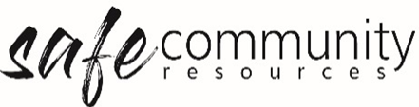
Safe Community Policy and Procedure Implementation & Review Schedule
Framework element | Implemented (Date) | People / Person Responsible | Review Due
Implementation of Policy / Procedure
Safe Community Framework Policy
Safe Community Framework Implementation Procedure
Participation & Inclusion of Children and their Caregivers
Recruitment & Appointment of Workers
Training & Resourcing of Workers
Supervision of Workers
Codes of Conduct Implemented
Safe Environments
Responding to Child Protection Concerns (child safety specific)
Responding to Safe Community Concerns about an Adult
Responding to Incidents & Emergencies
Record-keeping
Resolving Misunderstandings and Conflicts
Workplace Investigation
Appointment / Induction into roles
Safe Community Officer / Team
Head of Entity/ Agency/Organisation
Health & Safety Officer / Team
Coordinator / Program Leader/s
Management Group
Team Members

Copyright © 2020 Safe Ministry Resources Pty Ltd

The Safe Community Framework is developed and owned by SMR Pty Ltd.
This document cannot be modified without express written permission through a licence agreement. Please contact Safe Community Resources at info@safercommunities.net.au to seek permission.
Safe Community Resources can also provide customisation services to your organisation in the area of implementation of the Safe Community Framework for your organisation.

Disclaimer: This publication is not legal advice. The ideas and procedures herein are based on nationally recognised good practice advice and have been written with due regard to Australian legislation March 2020.
Legal advice may need to be sought when responding to individual incidents.

