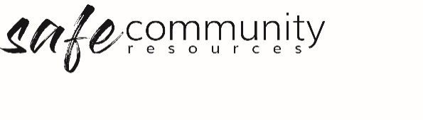

Safe Community Program Review
Leadership/Worker Interview

Year: ______________
Program Leader: _______________________________________
Program Name: ________________________________________

Use some or all of the following questions to help guide your Safe Community review interview.
a. In what ways have you incorporated the Safe Community Framework in your work?

b. What did we do well as a Safe Community team?

c. How did the program participants grow in their understanding of the Safe Community Framework?

d. How can our team better our Safe Community practices / procedures next year/time?

Is there any information relating to your suitability to continue in this role that we should know about?
No / Yes (Please List)

Have there been any incidents that you were involved in, either directly or indirectly, which were of a child protection nature, or have you ever, to your knowledge, been accused of sexual misconduct or abuse?
If yes, could you describe that incident?

TEAM COMMITMENT
I am willing to make a commitment to team leadership. In becoming a leader, I agree to adhere to the team leadership conduct covenant and to attend team meetings and in-service training.
I commit to this team for ____months at the end of which I will renew my commitment to the team or alternatively give my team leader notice that I wish not to continue in this role.

Signature of applicant:
Names and signatures of the interviewers:
Date:

Copyright © 2020 Safe Ministry Resources Pty Ltd

The Safe Community Framework is developed and owned by SMR Pty Ltd.
This document cannot be modified without express written permission through a licence agreement. Please contact Safe Community Resources at info@safercommunities.net.au to seek permission.
Safe Community Resources can also provide customisation services to your organisation in the area of implementation of the Safe Community Framework for your organisation.

Disclaimer: This publication is not legal advice. The ideas and procedures herein are based on nationally recognised good practice advice and have been written with due regard to Australian legislation March 2020.
Legal advice may need to be sought when responding to individual incidents.

