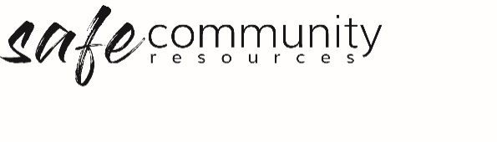

Sign in for Contractors and Guests
(for all occasions)

Sign in for Contractors and Guests (for all occasions)
Please read this declaration and sign in, to state that you will abide by the site expectations.
In performing tasks on the organisation's premises, I agree to:
- treat all people politely, with respect and dignity
- care for my own and others’ safety
- not act in ways that will put people in danger
- follow any reasonable instruction given to me by the leadership
I declare that I have not:
- been convicted /committed any crime against a child
- been convicted /committed any sexually related offense
By signing below and entering your details you are making this commitment to safety and declaration.
Date | Name | Signature | Reason for visit | Time in | Time out

SAMPLE Declaration for contractors seeking to provide goods/services at children’s events (e.g. Fun Day, Fetes or Carols)
In performing tasks on site at <insert your organisation's name> ON <insert date> for the <insert event/s>
I agree to:
- treat all people on site politely, with respect and dignity
- care for my own and others safety
- not acting in ways that will put people in danger
- follow any reasonable instruction given to me by the leader/s who have contracted me to carry out tasks for the organisation.
Matters to disclose (if any):
____________________________________________________________________________
____________________________________________________________________________
____________________________________________________________________________
Declaration:
Other than those matters disclosed by me (noted above) at the time of making this declaration, I know of no past behaviour that renders me unfit to operate as a contractor or which detracts from the obligation of the organisation to operate as a place of safety to a minor or any other person. Such past behaviour may include being the subject of any allegation of sexual abuse (whether convicted or not), including any type of molestation, indecent exposure, sexual harassment, or intimidation.
Name:
Company:
WWC Check Number (if required):
Trade licence Number (if required):
Signature:
Date:

If you are unable to make this commitment and declaration, please speak with the organisation leader who has contracted you.

Copyright © 2020 Safe Ministry Resources Pty Ltd

The Safe Community Framework is developed and owned by SMR Pty Ltd.
This document cannot be modified without express written permission through a licence agreement.
Please contact Safe Community Resources at info@safercommunities.net.au to seek permission.
Safe Community Resources can also provide customisation services to your organisation in the area of implementation of the Safe Community Framework for your organisation.

Disclaimer: This publication is not legal advice. The ideas and procedures herein are based on nationally recognised good practice advice and have been written with due regard to Australian legislation March 2020.
Legal advice may need to be sought when responding to individual incidents.

