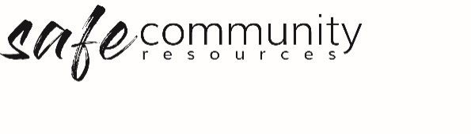

Site Safety Expectations Poster
(for Contractor & Guests)
(Use this information for a small sign to sit next to the contractor sign in booklet)

Our organisation is a safe place for everyone.

We expect all contractors and visitors to
- respect each other
- care for each other’s safety
- report any concerns about people’s safety to their contact person

To ensure the safety of all people
- there is to be no unsupervised visitor alone with a child or group of children
- all visitors must sign in and declared that they are a safe person, and that they will act in safe ways towards others

Copyright © 2020 Safe Ministry Resources Pty Ltd

The Safe Community Framework is developed and owned by SMR Pty Ltd.
This document cannot be modified without express written permission through a licence agreement. Please contact Safe Community Resources at info@safercommunities.net.au to seek permission.
Safe Community Resources can also provide customisation services to your organisation in the area of implementation of the Safe Community Framework for your organisation.

Disclaimer: This publication is not legal advice. The ideas and procedures herein are based on nationally recognised good practice advice and have been written with due regard to Australian legislation March 2020.
Legal advice may need to be sought when responding to individual incidents.

