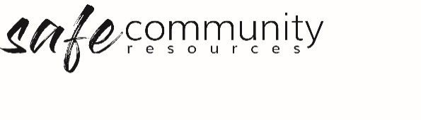

Staff and Governance Board
Interview Questions
This form is a suggested starting point for interviewing a potential program team member. Before starting the interview, inform the applicant that their answers may be disclosed to appropriate leaders in the organisation.
a. Can you describe more fully the reasons you desire to be involved with this organisation?

b. Can you describe a positive experience from your past work experience?

c. Can you describe a negative experience from your past work experience?

d. Do you consider yourself a positive role model? Why/not?

e. Is there any other information relating to your suitability for this organisation?

f. [add in organisation-specific questions]

- Read through the code of conduct together.

- Read through and discuss any YES responses to the screening check questionnaire.

Date of interview:
Name and signature of applicant:
Names and signatures of the interviewers:

Copyright © 2020 Safe Ministry Resources Pty Ltd

The Safe Community Framework is developed and owned by SMR Pty Ltd.
This document cannot be modified without express written permission through a licence agreement. Please contact Safe Community Resources at info@safercommunities.net.au to seek permission.
Safe Community Resources can also provide customisation services to your organisation in the area of implementation of the Safe Community Framework for your organisation.

Disclaimer: This publication is not legal advice. The ideas and procedures herein are based on nationally recognised good practice advice and have been written with due regard to Australian legislation March 2020.
Legal advice may need to be sought when responding to individual incidents.

