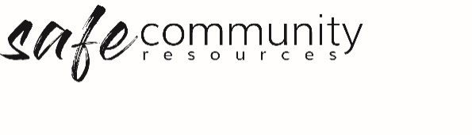

Workplace Health and Safety Policy (SAMPLE)

The <insert your organisation name> recognises its moral and legal responsibility to provide a safe and healthy work environment for everyone.
All people at this organisation will endeavour to do nothing to place themselves or others at risk of emotional or physical injury or illness.
The senior leadership (board of management) will endeavour to:
• Provide a safe workplace including a safe site and safe programs
• Ensure compliance with legislative requirements and standards
• Provide workers (volunteers and paid) and contractors with information, instruction, training, and supervision for their safety
• Provide support that will assist workers in maintaining their psychological and physical health
• To implement Work Health and Safety policies and procedures
• Actively promote and be involved in the implementation of those policies and procedures
All workers (volunteer and paid) are responsible for:
• Following all health and safety policies and procedures
• Reporting all hazards identified to the Health and Safety team
• Complying with reasonable instructions
• Not behaving in a wilful or reckless manner

The organisation is committed to encouraging consultation and cooperation between administrators, employees, and voluntary workers. It will involve all parties in workplace changes likely to affect their safety, health, and welfare.

Approved:

Name/role: …………………………………………………………………………………….

Date: …………/…………./………………

Copyright © 2020 Safe Ministry Resources Pty Ltd

The Safe Community Framework is developed and owned by SMR Pty Ltd.
This document cannot be modified without express written permission through a licence agreement. Please contact Safe Community Resources at info@safercommunities.net.au to seek permission.
Safe Community Resources can also provide customisation services to your organisation in the area of implementation of the Safe Community Framework for your organisation.

Disclaimer: This publication is not legal advice. The ideas and procedures herein are based on nationally recognised good practice advice and have been written with due regard to Australian legislation March 2020.
Legal advice may need to be sought when responding to individual incidents.

